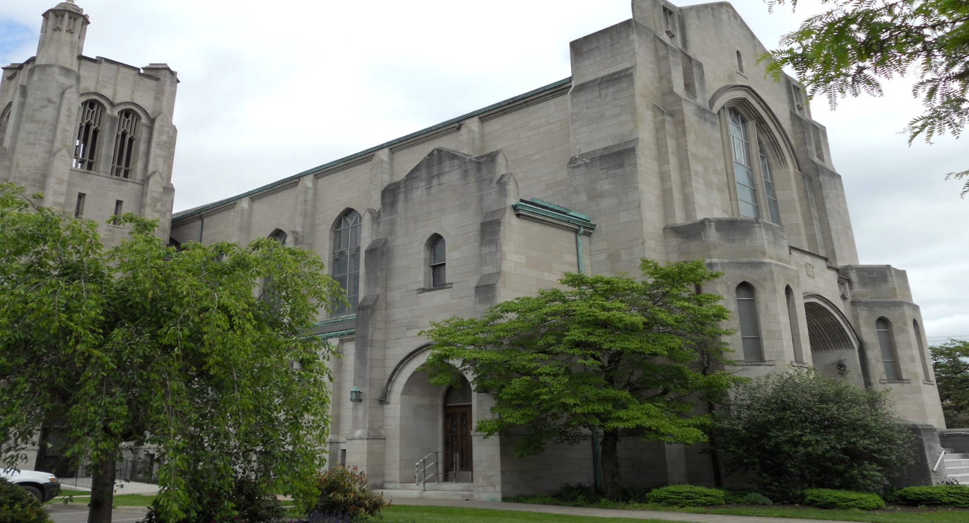

**Walk for Warmth**

Help your neighbor stay warm by raising money for the **Emergency Heating Assistance Fund**. The average household will spend $2,500 for oil heat this year, that’s up $700 dollars from three years ago. $400 dollars is the general request for one   
family. Our friends and neighbors need your help to keep their homes warm.

**Saturday, February 6, 2016**

**10:00 am—2:00 pm**

**High School Track, Berwick**(Snow or Shine)

**A warm-up tent will be provided.**

Call Ayrin Shortlidge for Pledge Forms and for more information   
570-759-8203 or email [coordinator@berwickareauw.org](mailto:coordinator@berwickareauw.org).

**Souper Bowl of Caring**

The Souper Bowl of Caring is just around the corner! This year we have decided to hold a soup sale. Two types of soup will be offered. Vegetable Beef and Chicken Bow Tie. Order forms can be found in your bulletin. A quart of soup will be $5. We hope you will join us on **February 7th for Souper Bowl Sunday**. We will hold fellowship downstairs and have soup available to eat and order pick up in the kitchen. We are also looking for volunteers to cook. If you would like to help out we will be meeting **Saturday February 6th at 9:30** in the kitchen. If you can’t make it but would like to help we will be accepting monetary donations to purchase supplies. You can leave your donations in the offering plate or in the office. Please note Souper Bowl with your donation. Thank you in advance for your support of this cause!

Presbyterian

*times*

*A monthly publication of the First Presbyterian Church of Berwick*

**february 2016**

**Be a Partner in Mission**

**through the Pentecost Offering**

When God poured out his Holy Spirit on the church at Pentecost, he created a new community—the church. There was an incredible unity among Christians at that time, according to Luke: *“All who believed were together and had all things in common; they would sell their possessions and goods and distribute the proceeds to all, as any had need. Day by day, as they spent much time together in the temple, they broke bread at home and ate their food with glad and generous hearts, praising God and having the goodwill of all the people”(Acts 2:44–47).*

It is this unifying Spirit that reveals to us the transforming and creative love of God that makes the impossible possible. That’s why the Pentecost Offering, one of four annual churchwide special offerings of the Presbyterian Church (U.S.A.), is so special and meaningful. Through the unifying, empowering presence of the Holy Spirit in our lives, the Pentecost Offering provides a tangible way to bring God’s transforming love to children at risk, guide and nurture the faith of young people, and call forth a new generation of church leadership through the PC(USA) Young Adult Volunteer (YAV) program. Ten percent of funds from the Pentecost Offering are used for child advocacy, 25 percent are used for youth ministry, 25 percent go to the YAV program, and each congregation keeps 40 percent for ministries benefiting children at risk. You can see a detailed breakdown of how these funds are spent at pcusa.org/pentecost.

**Please see the next page for more information on the Pentecost Offering**

*Beyond Violence*

*Congregational Meeting*

*Who’s in the Pulpit?*

*Ash Wednesday*

*Grab a Tab*

*We Are Growing!*

*Blue Out*

*Children’s Bulletin*

*Deacon Happenings*

*January Birthdays/Anniversary’s*

*January Assistants*

**In this Issue**





**Ash Wednesday Service**

We will be holding an Ash Wednesday service **February 10th at 7:00**. Communion will be served!

**Grab a Tab Program**

Last year we started the Grab a Tab program. It is an easy **free** way to support a local nonprofit. The pull tabs are collected by Ronald McDonald House in Danville and are turned into cash to benefit their ongoing operations and programs. Before you toss out those cans pull the tab and bring them to church. There is a collection can on the back table of the sanctuary! Last year we donated 8 pounds of tabs to benefit Ronald McDonald House! Can we beat last year’s total? Keep grabbing those tabs to find out!

**We Continue to Grow!**

Our Girl Scouts are growing in numbers! A second group of eager young scouts are meeting in the scout room on Tuesday evenings! The leader of our Girl Scout group has taken on the task of educating a new group of young aspiring scouts that are just starting out.

**Beyond Violence Annual Gala**

Beyond Violence will be holding their annual Gala Party and Raffle **February 6th from 6-11** at the Rolling Pines Golf Course. Tickets are available through mail from Beyond Violence, Inc (1612 Walnut Street, Berwick, PA 18603, 570-759-0298) or any board member. A $125 donation guarantees your opportunity to participate in the drawing and admits a party of two to an evening of music and merriment for the benefit of a worthy cause.  
  
Ticket cost includes dinner and dancing for two (cash bar) and 1 entry for the $5000 cash prize. There will also be other Chinese auction items available. The winner of the drawing does not need to be present to win.  
Only 300 tickets will be sold!   
Make checks payable to Beyond Violence, Inc.

**Congregational Meeting**

Our congregational meeting will be held following fellowship in the fellowship hall **Sunday February 7th**. All members are asked to attend.

**Who’s in the Pulpit?**

This month we will welcome Robert Kribbs, a ruling elder from Lewisburg as pulpit supply **on February 28th**!

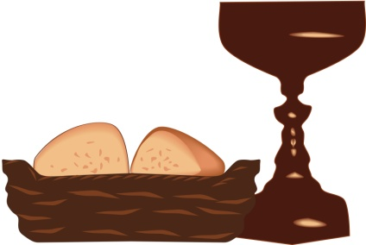

**Join the Blue Out!**

We have entered the season of Lent and the promotion period for the One Great Hour of Sharing (OGHS) offering. The season of Lent is a time for repentance, service, reflection, and prayer as we consider how Christ gave himself to others.

The first Sunday in Lent (February 14, 2016) has been designated “Wear your blue t-shirt to church Sunday” as a testament of one of the ways One Great Hour of Sharing makes a difference.

We want to encourage you to acknowledge the first Sunday in the season by reflecting on your service to families recovering from the agony of disaster. Although the liturgical color for the season is purple, wearing blue on the first Sunday of Lent can be a symbol of hope for the recovery and restoration of life that we know will come for survivors.  Would you participate in the sign of hope that the blue represents? Help raise awareness by wearing blue clothing, hats, flowers, balloons, and so forth. And spread the word!

As you prepare to take the [One Great Hour of Sharing](http://specialofferings.pcusa.org/oghs) offering, remember that your gifts witness to the healing love of Christ and bring hope out of the chaos of disaster, supporting disaster recovery efforts in the United States and around the world.

**Communion Dates 2016**

February 7

February 10

March 6

March 24

March 27

May 1

June 5

July 3

August 7

September 4

October 2

November 6

December 4

December 24

**Children’s Bulletins**

**Each Sunday** we will be offering worship bulletins for our younger worship attendees. This activity filled bulletin will follow the adult lectionary and prepare the children for their Sunday school lesson. If you have a child that would like to have *their own* bulletin for worship they can be found in the narthex! There are also crayons and books in the box in the back corner of the sanctuary!

**Easter Candy!**

The Deacons have officially kicked off their Easter egg, pretzel and bunny pop fundraiser. They will be offering peanut butter and coconut eggs in milk, and dark chocolate. Pretzels and bunny pops will be available in milk and dark chocolate. These are awesome for Easter baskets or to satisfy your sweet tooth! Please make checks payable to Presbyterian Deacons. Please use your order form in your bulletin or call the office to place your order! **Orders will be accepted until March 20th.**

**Deacon Happenings**

The Deacons held a collection drive for hats, gloves and socks during the month of January when they heard of a need for these items for students in the elementary schools in our district. The Deacons purchased a large quantity of these items and opened the drive to the congregation. Thanks to everyone **250 items** were delivered to the district office in January. Thank you to all in helping the many students keep warm this winter!

Also in January, the Deacons met to make turkey chili and chicken noodle soup to fill up the church freezer for those in need. The change that was collected from the Two Cent a Meal cans was used to make all the soup. 40 quarts in total were made. Thank you for collecting change throughout the year to benefit those less fortunate!



**February Birthdays**

James Ross 2/1

Mary Creasy 2/3

David Corl Jr. 2/14

Joan Botto 2/19

Robert Johnson 2/20

Brian Remley 2/21

Carolyn White 2/25

Dr. Harold Johnson 2/26

**Happy Birthday!**

**February 21**

**Greeters:** Janice Moskaluk, Alison Hause

**Ushers**: Dave Force, Stone Force

**Assisting Elder:** Barb Huntington

**Acolyte:** Giuliana Force

**February 28**

**Greeters:** MaryAnn Marshman, Fran Kirchdoerfer

**Ushers:** Ernie Botto, Keith Botto

**Assisting Elder:** Penny Siesko

**Acolyte:** Aaliyah DAngelo

**February Deacon Visitor:** Steve & Karen Hiller

**February 7 Souper Bowl**

**Greeters:** The Doll Family

**Ushers:** Walter & Alison Hause

**Assisting Elder:** Penny Siesko

**Acolyte:** Miles Doll

**February 10 Ash Wednesday**

**Greeters:** Jay & Nancy Dietterick

**Assisting Elder:** Joan Thomas

**February 14**

**Greeters:** The Birt Family

**Ushers**: Joan Thomas, Eugeniu Grigorescu

**Assisting Elder:** Nancy Dietterick

**Acolyte:** Tyrone Birt



**First Presbyterian Church**

*320 Market Street*

*Berwick, PA 18603*

***Mail to:******PO Box 325***

*570-759-9461*

[*bwkpresby@pa.metrocast.net*](mailto:berwickpresbyterian@verizon.net)

www.bwkpresby.org



**Worship service 10:15am**

**Sunday school for all ages during worship**

**Nursery available**

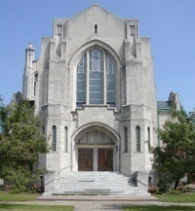

## **Have a wonderful month with family and friends!**

## **February Assistants**